Instructions: Test the SmartPower Sink & Surface Cleaner Sanitizer Dispenser’s solution using the Sink & Surface Cleaner Sanitizer Test Strips. Check the box on the log if the concentration is satisfactory or unsatisfactory. Follow the Sink & Surface cleaner sanitizer testing instructions below:

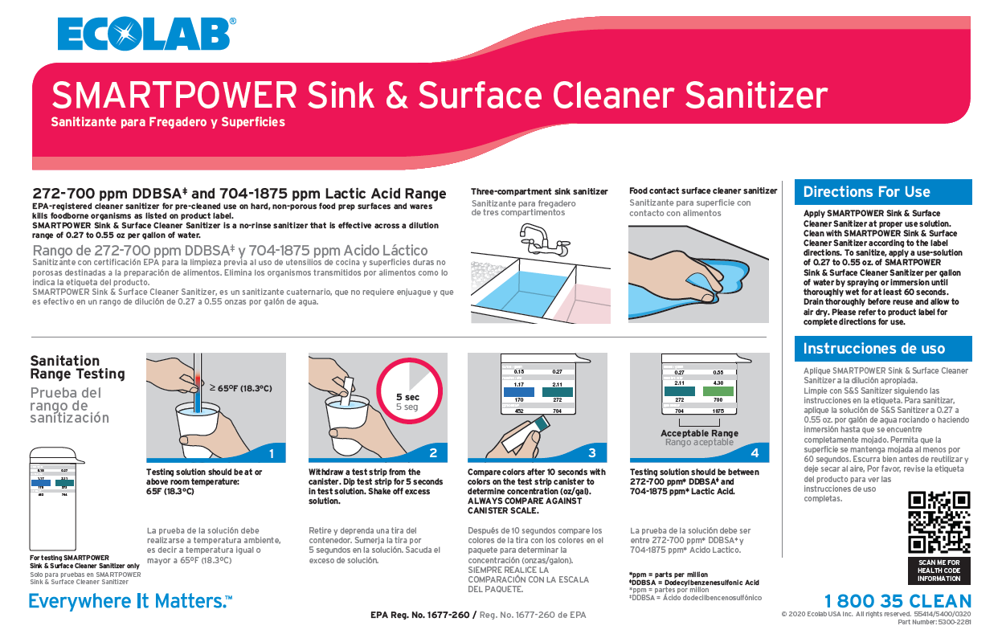
Fill-out the form on the next page accordingly:
(1) Dispenser Location: Document the name/location of the dispenser
(2) Month/Year: Document the month/year (Example: June 2024)
(3) Date: Document the date of testing the sanitizer solution
(4) Time: Document the time of testing the sanitizer solution
(5) Satisfactory: Mark an “X” in this column if the sanitizer solution is testing in the correct range for the specific solution
(6) Unsatisfactory: Mark and “X” in this column if the sanitizer is not testing in the correct range for the specific solution. Contact manager and adjust dispenser (chemical company must adjust the calibration)
(7) Temperature Mark an “X” if the solution temperature is 65°F (18°C) & above.
(8) Corrective Actions: Highlight any results outside proper operating ranges and comment on reason. Inform supervisor or person-in-charge (PIC or GM)/manager. Record corrective actions taken.
(9) Employee’s Initials: Employee responsible for testing the sanitizer
(10) Manager’s Initials/Signature: Manager or person-in-charge (PIC) initial or signature. The Manager or PIC must review data entry and sign this document within 7 days.

Standard/Critical Limit:
Ecolab S&S Sanitizer: 0.27 - 0.55 oz/gal (correlates with 272 - 700 ppm Dodecyl benzenesulfonic and 704 – 1875 ppm Lactic Acid). Testing solution should be at or above room temperature: 65°F (18.3°C). Check the expiration date of the test kit to ensure it is not expired before use.

Corrective Actions: Notify manager and adjust chemical concentration as needed, adjustments to the dispenser must be made by the chemical company.

Note: Manager must review and sign this log within 7 days. Employees responsible for testing and recording the sanitizer solution concentrations must be trained in this procedure.

(1) Dispenser Location: |  | (2) Month/ Year

(3)  Date | (4)  Time | (5)  Satisfactory | (6)  Unsatisfactory | (7)  Temperature Above 65°F (18.3°C) | (8)  Corrective Actions/Comments | (9)  Employee’s  Initials | (10)  Manager’s Initials/ Signature
1 |  | ☐ | ☐ | ☐
2 |  | ☐ | ☐ | ☐
3 |  | ☐ | ☐ | ☐
4 |  | ☐ | ☐ | ☐
5 |  | ☐ | ☐ | ☐
6 |  | ☐ | ☐ | ☐
7 |  | ☐ | ☐ | ☐
8 |  | ☐ | ☐ | ☐
9 |  | ☐ | ☐ | ☐
10 |  | ☐ | ☐ | ☐
11 |  | ☐ | ☐ | ☐
12 |  | ☐ | ☐ | ☐
13 |  | ☐ | ☐ | ☐
14 |  | ☐ | ☐ | ☐
15 |  | ☐ | ☐ | ☐
16 |  | ☐ | ☐ | ☐
17 |  | ☐ | ☐ | ☐
18 |  | ☐ | ☐ | ☐
19 |  | ☐ | ☐ | ☐
20 |  | ☐ | ☐ | ☐
21 |  | ☐ | ☐ | ☐
22 |  | ☐ | ☐ | ☐
23 |  | ☐ | ☐ | ☐
24 |  | ☐ | ☐ | ☐
25 |  | ☐ | ☐ | ☐
26 |  | ☐ | ☐ | ☐
27 |  | ☐ | ☐ | ☐
28 |  | ☐ | ☐ | ☐
29 |  | ☐ | ☐ | ☐
30 |  | ☐ | ☐ | ☐
31 |  | ☐ | ☐ | ☐

Highlight any results outside proper operating ranges and comment on reason. Inform person in charge/supervisor. Check the expiration date of the test kit to ensure it is not expired before use. Record corrective actions.
Ecolab S&S Sanitizer: 0.27 – 0.55 oz/gal (correlates with 272 - 700 ppm Dodecyl benzenesulfonic and 704 – 1875 ppm Lactic Acid. Testing solution should be at or above room temperature: 65°F (18.3°C).

